Seif Kamal

202101838

Lab 4

Question 1:

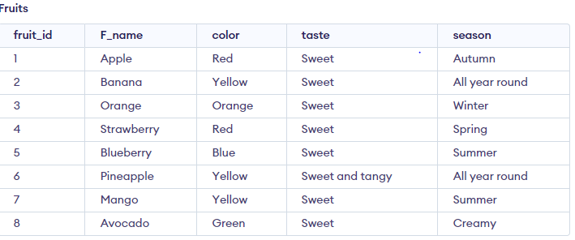

Question 2:

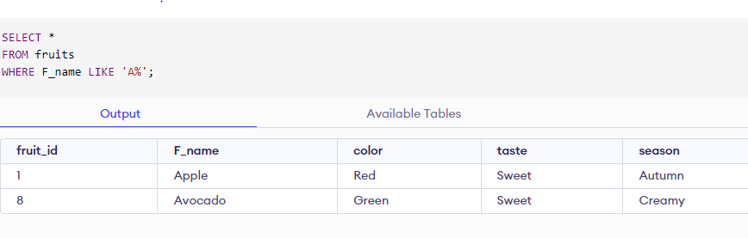

Question 3:

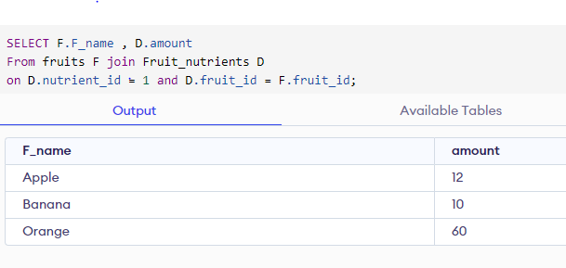

Question 4:

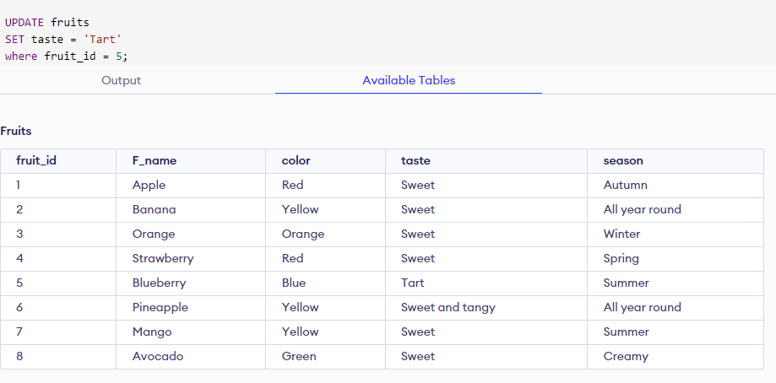

Question 5:

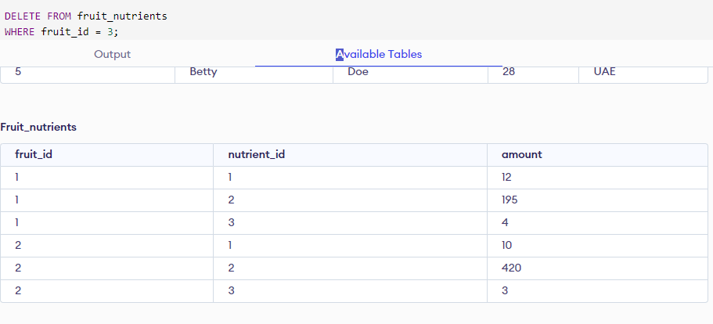

Question 6:

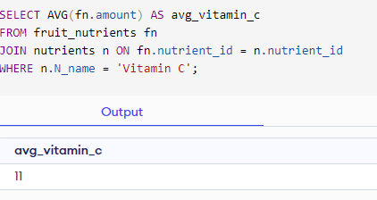

Question 7:

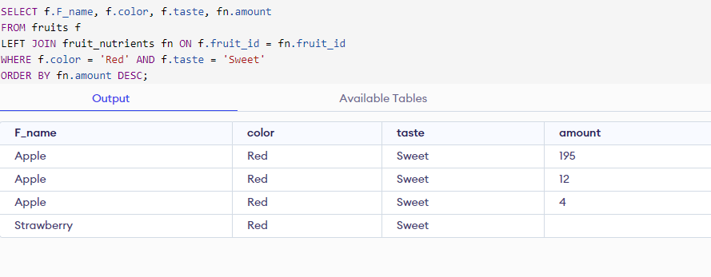

Code:

-- Online SQL Editor to Run SQL Online.

-- Use the editor to create new tables, insert data and all other SQL operations.

-- Online SQL Editor to Run SQL Online.

-- Use the editor to create new tables, insert data and all other SQL operations.

-- Online SQL Editor to Run SQL Online.

-- Use the editor to create new tables, insert data and all other SQL operations.

-- Online SQL Editor to Run SQL Online.

-- Use the editor to create new tables, insert data and all other SQL operations.

-- Online SQL Editor to Run SQL Online.

-- Use the editor to create new tables, insert data and all other SQL operations.

-- Online SQL Editor to Run SQL Online.

-- Use the editor to create new tables, insert data and all other SQL operations.

-- Online SQL Editor to Run SQL Online.

-- Use the editor to create new tables, insert data and all other SQL operations.

-- Online SQL Editor to Run SQL Online.

-- Use the editor to create new tables, insert data and all other SQL operations.

-- Online SQL Editor to Run SQL Online.

-- Use the editor to create new tables, insert data and all other SQL operations.

/*CREATE TABLE fruits (

fruit_id INT PRIMARY KEY,

F_name VARCHAR(50),

color VARCHAR(20),

taste VARCHAR(50),

season VARCHAR(20)

);

INSERT INTO fruits (fruit_id, F_name, color, taste, season)

VALUES (1, 'Apple', 'Red', 'Sweet', 'Autumn'),

(2, 'Banana', 'Yellow', 'Sweet', 'All year round'),

(3, 'Orange', 'Orange', 'Sweet', 'Winter'),

(4, 'Strawberry', 'Red', 'Sweet', 'Spring'),

(5, 'Blueberry', 'Blue', 'Sweet', 'Summer'),

(6, 'Pineapple', 'Yellow', 'Sweet and tangy', 'All year round'),

(7, 'Mango', 'Yellow', 'Sweet', 'Summer'),

(8, 'Avocado' , 'Green' , 'Sweet', 'Creamy');

CREATE TABLE nutrients (

nutrient_id INT PRIMARY KEY,

N_name VARCHAR(50),

unit VARCHAR(20)

);

INSERT INTO nutrients (nutrient_id, N_name, unit)

VALUES (1, 'Vitamin C', 'mg'),

(2, 'Potassium', 'mg'),

(3, 'Fiber', 'g'),

(4, 'Vitamin A', 'IU'),

(5, 'Calcium', 'mg'),

(6, 'Iron', 'mg');

CREATE TABLE fruit_nutrients (

fruit_id INT,

nutrient_id INT,

amount DECIMAL(10,2),

FOREIGN KEY (fruit_id) REFERENCES fruits(fruit_id),

FOREIGN KEY (nutrient_id) REFERENCES nutrients(nutrient_id)

);

INSERT INTO fruit_nutrients (fruit_id, nutrient_id, amount)

VALUES (1, 1, 12),

(1, 2, 195),

(1, 3, 4),

(2, 1, 10),

(2, 2, 420),

(2, 3, 3),

(3, 1, 60),

(3, 2, 235),

(3, 3, 4);*/

/*SELECT *

FROM fruits

WHERE F_name LIKE 'A%';*/

/*SELECT F.F_name , D.amount

From fruits F join Fruit_nutrients D

on D.nutrient_id = 1 and D.fruit_id = F.fruit_id;*/

/*UPDATE fruits

SET taste = 'Tart'

where fruit_id = 5;*/

/*DELETE FROM fruit_nutrients

WHERE fruit_id = 3;*/

/*SELECT AVG(fn.amount) AS avg_vitamin_c

FROM fruit_nutrients fn

JOIN nutrients n ON fn.nutrient_id = n.nutrient_id

WHERE n.N_name = 'Vitamin C';*/

SELECT f.F_name, f.color, f.taste, fn.amount

FROM fruits f

LEFT JOIN fruit_nutrients fn ON f.fruit_id = fn.fruit_id

WHERE f.color = 'Red' AND f.taste = 'Sweet'

ORDER BY fn.amount DESC;